**MEETRS web application instructions for uploading Withholding or Unemployment files, W-3ME Annual Reconciliation files, W-2 Annual Wage and Payment Statements or 1099/W2-G Non-wage Payment Statements**

Welcome Page 2

Information Page 3

Maine MEETRS File Formatting Specifications 4

Registration 5

First Time Logon 6

Password 7

Change Business Information 8

Registration and Select Activity 9

Upload File 10

Feedback Examples 15

Confirmation 16

Display Confirmed Transmission 17

Display Transmission Detail List 18

Display Employer Detail List 20

Display Employee Detail 23

Display Transmission Summary 24

Print Pay Voucher(s) 26

This document explains how to use the Maine Employers Electronic Tax Reporting System (MEETRS). Each relevant web page utilized during the upload process is presented along with a descriptive commentary about that page.

Welcome Page

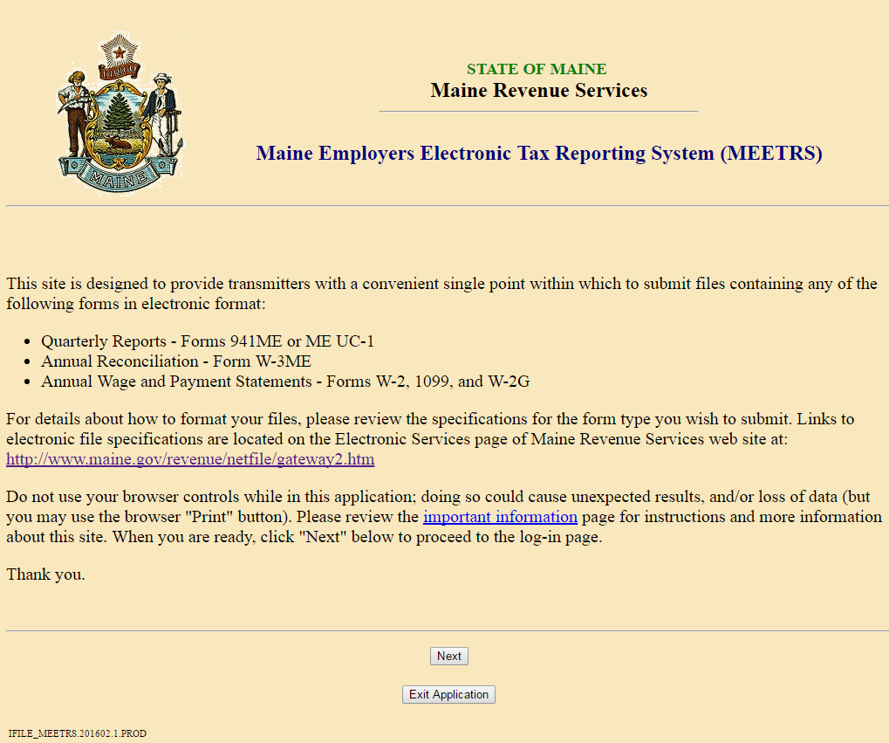

The Welcome page is presented when you launch the MEETRS Upload application.

Information Page

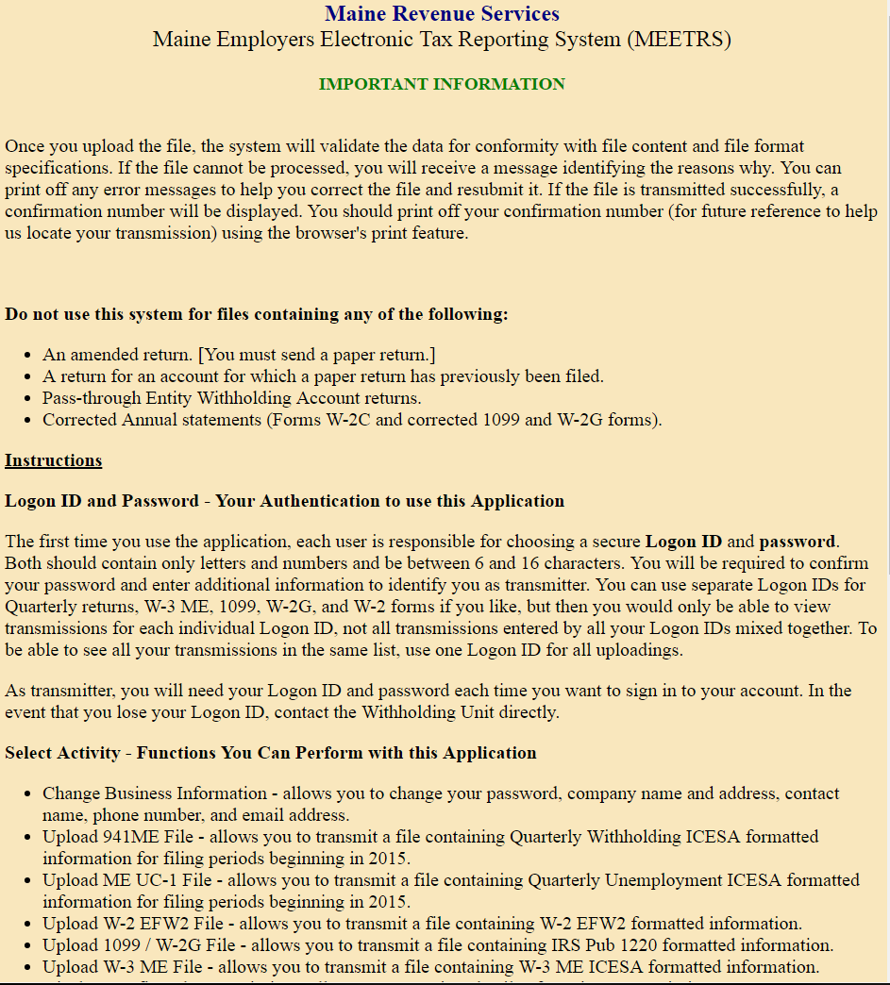

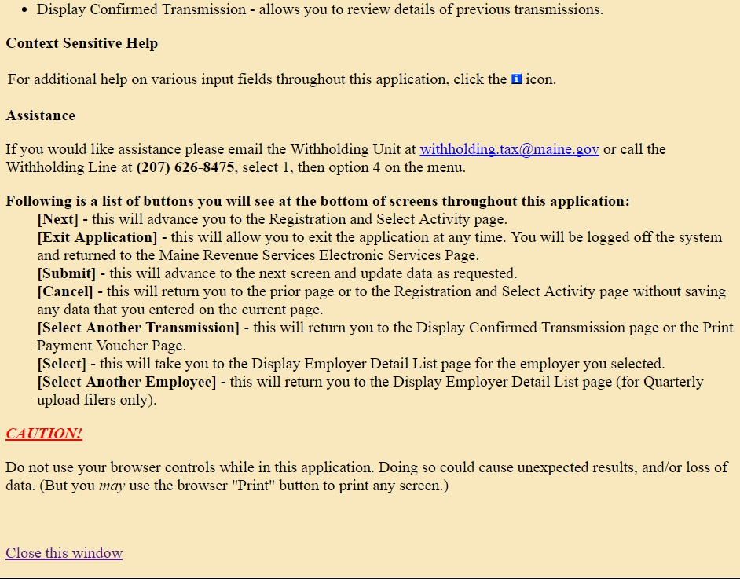

The Information page provides general information about the MEETRS Upload application.

Maine MEETRS File Formatting Specifications

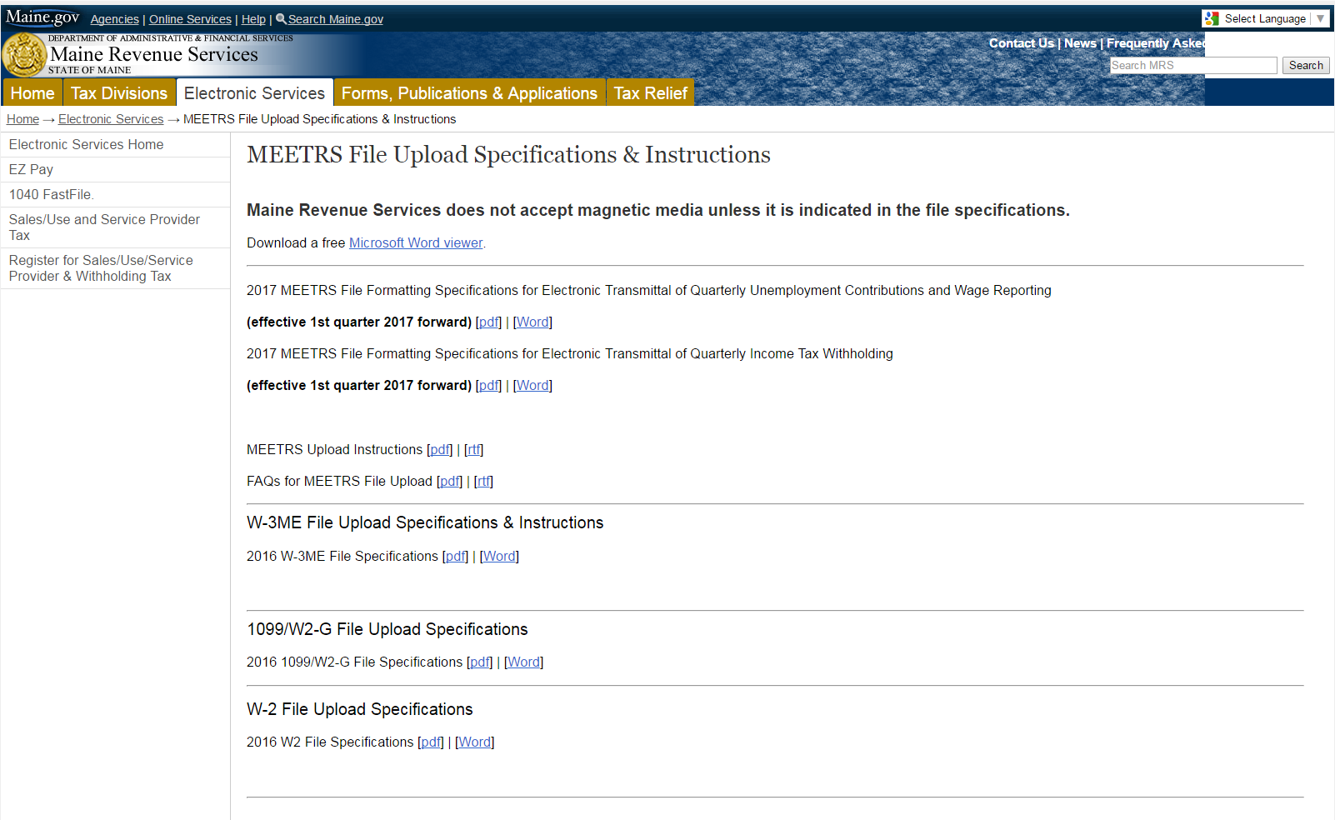

The MEETRS File Upload Specifications and Instructions, located on the Electronic Services page, provides a link to specific information about the nature, content and format of Withholding files, Unemployment files, W-3ME files, W-2 files, and 1099/W2-G files. To access the information, click on the specifications links for the type of file you wish to upload.

**Registration**

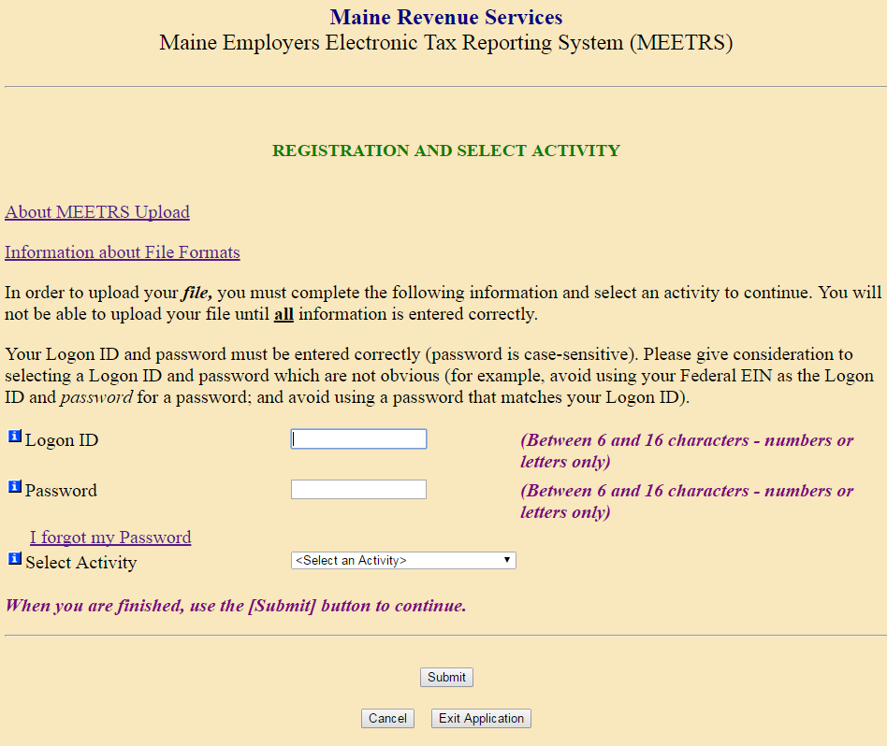

The Registration page allows you (the transmitter) to log on to the MEETRS Upload application, to get help about the application and the file formatting rules (by clicking on links at the top of the page), to obtain your password, and to perform several activities (using the Select Activity drop down menu).

The first time you use the application, you create a Logon ID and password. You will also need to confirm your password and enter additional information to identify you as transmitter, including your Federal EIN. (Instructions are on the following page.)

Rules for creating a unique Logon ID:

* Must be 6-16 characters
* May use a combination of letters or numbers only
* Cannot contain spaces
* Cannot be a duplicate of your password

Additional suggestions:

* If the Logon ID you've chosen is already taken, try adding a number (such as "jsmith1" instead of "jsmith").
* Use a phrase (without any spaces between words).

As transmitter, you will need your Logon ID and password each time you want to sign in to your account.  In the event that you lose your Logon ID, contact the Withholding Unit directly at (207) 626-8475, select 1, option 4.

First Time Logon

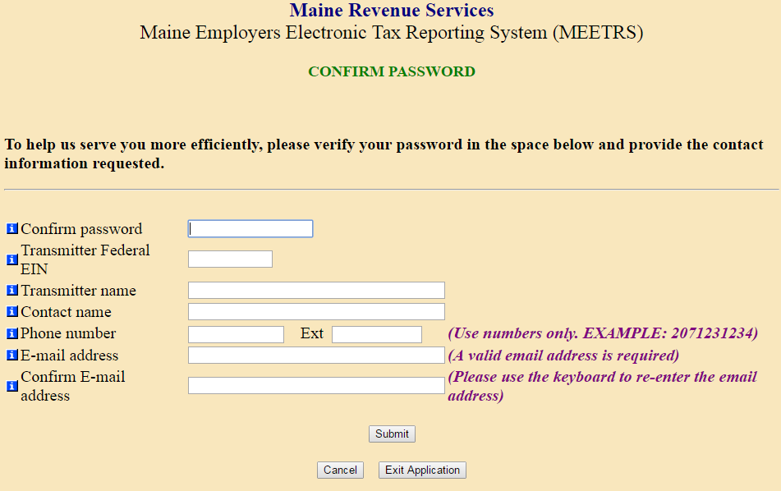

The first time you use the application as a transmitter, you may choose “Upload File”, and the application will take you to the Confirm Password screen.

MEETRS Upload collects information to identify you so MRS can contact you if necessary and to authenticate you when you use the application in the future. **The transmitter Federal EIN must match the Transmitter (A) Record, location 6 – 14.**

Please be sure to maintain an up-to-date email address as it may be used to notify you of any changes or problems with the MEETRS system.

Password

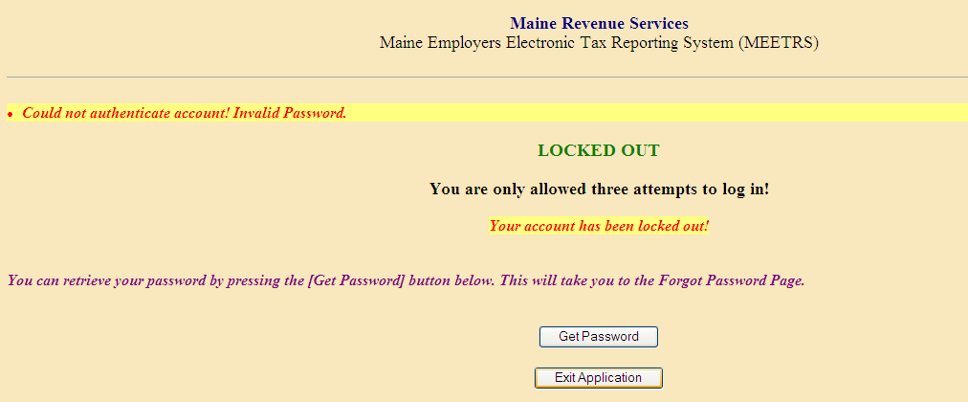

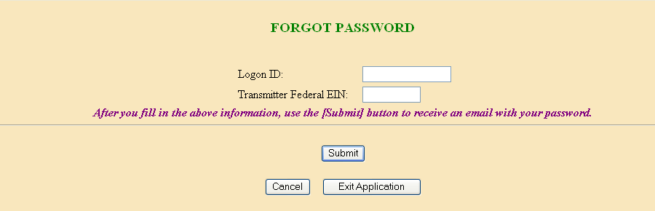

MEETRS Upload gives you three chances to enter the Logon ID and password, then the application logs off. If this happens you can restart the application and ask MRS to send the password via email by clicking on the “I forgot my password” link on the Registration page. Your password will be sent to the email address identified on the Business Information Page (next).

If you do not have an email address or there are errors when you press submit on Forgot Password, call Maine Revenue Services at 207-626-8475, press 1, then choose option 4.

**Change Business Information**

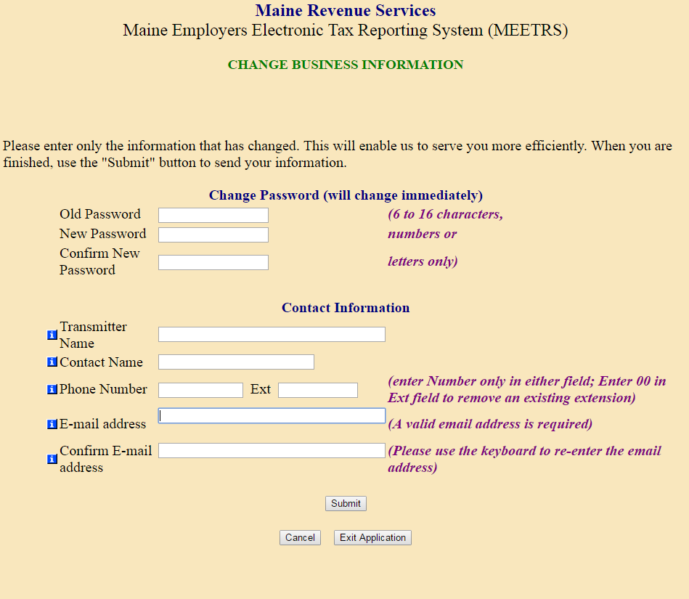

You can update information about the Transmitter on the Change Business Information screen.

It is important to keep your Contact Information up to date.

**Registration and Select Activity**

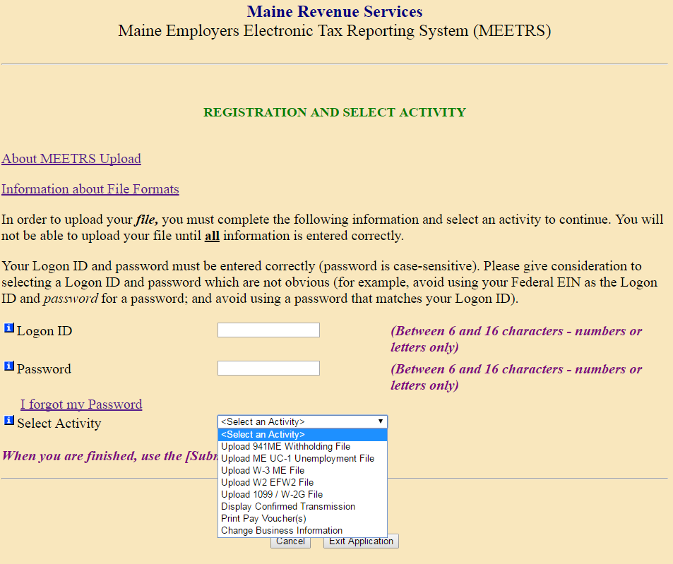

In order to move from one activity to the next, you have to reenter your Logon ID and Password. The Transmitter may select any of the following activities:

1) Upload 941ME Withholding File (this option may be used to test files);

2) Upload ME UC-1 Unemployment File (this option may be used to test files);

3) Upload W-3ME File (this option can also be used to test files);

4) Upload W2 File (this option can also be used to test files);

5) Upload 1099/W2-G File (this option can also be used to test files);

6) Display Confirmed Transmission (this option can be used for quarterly returns, W-3ME annual reconciliations, W-2 files, and 1099/W2-G files);

7) Print Pay Voucher(s);

8) Change Business Information.

Clicking the Submit button will take you to the appropriate page provided you have entered an appropriate Logon ID and password.

**Upload File**

As transmitter, you specify information about the file and point to the file you wish to upload with the Browse button, then press Submit. The information you supply varies depending on the activity selected (in this example of a Quarterly file upload you would specify the Quarter, Year and Total Employers).

**941ME / ME UC-1**

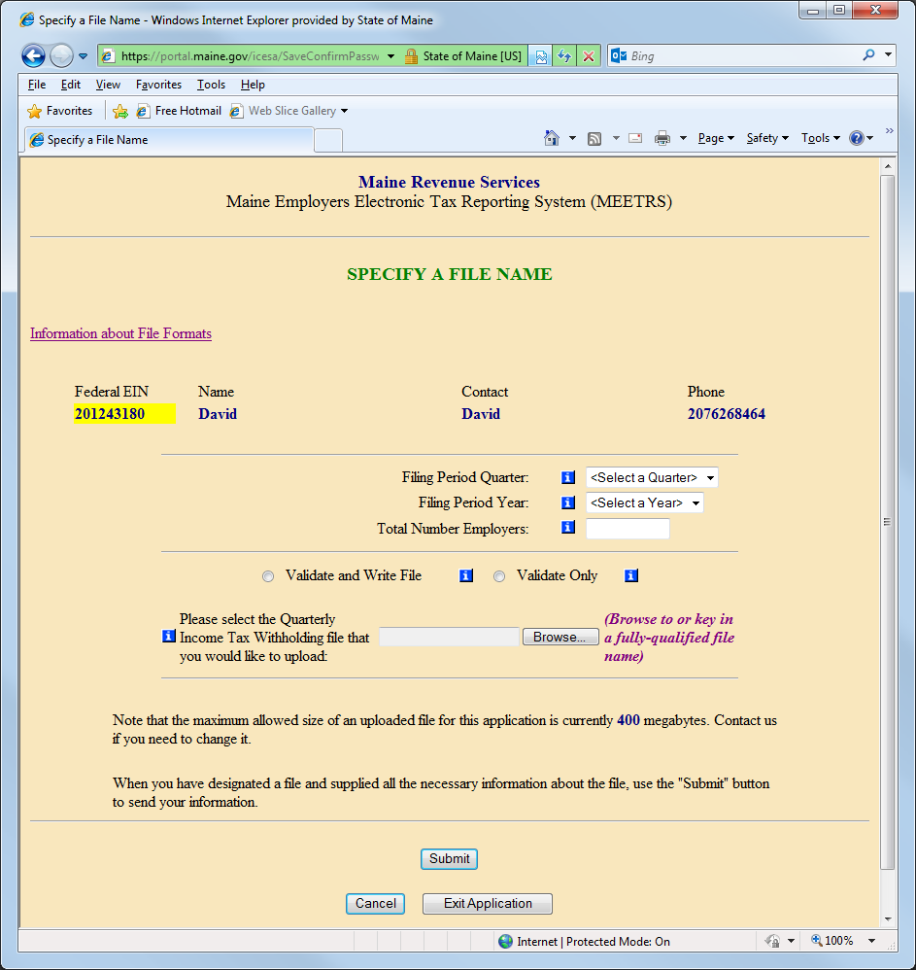

The file must be a text file with .txt extension, you may assign any name. Note that the maximum allowed size of an uploaded file for this application is currently 400 megabytes. Contact us if you need to change it.

**W-3_ME File**

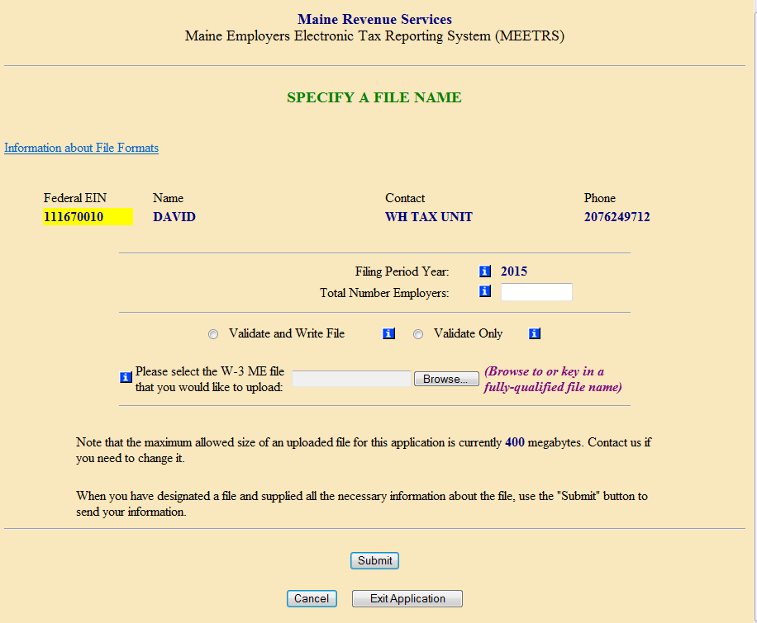

You need to enter the Total Number of Employers to upload a W-3ME file. The Filing Period Year is hard coded for the currently due tax year.

**W2 EFW2 File**

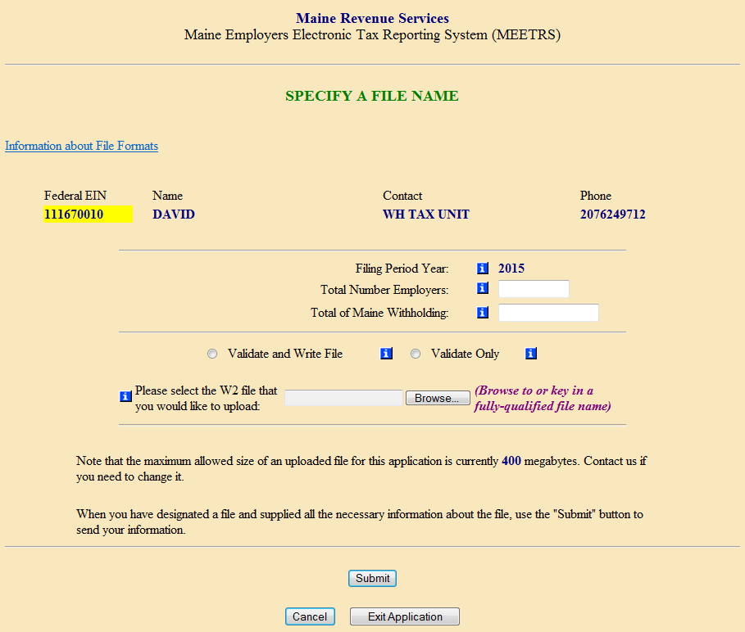

You need to enter the Total Number of Employers and the Total of Maine Withholding to upload a W2 file. The Filing Period Year is hard coded for the currently due tax year.

MEETRS Upload warns that the operation may take a while! For very large files, there is a substantial delay (minutes).

Press the OK button on the dialogue box to continue.

**1099/W2-G file**

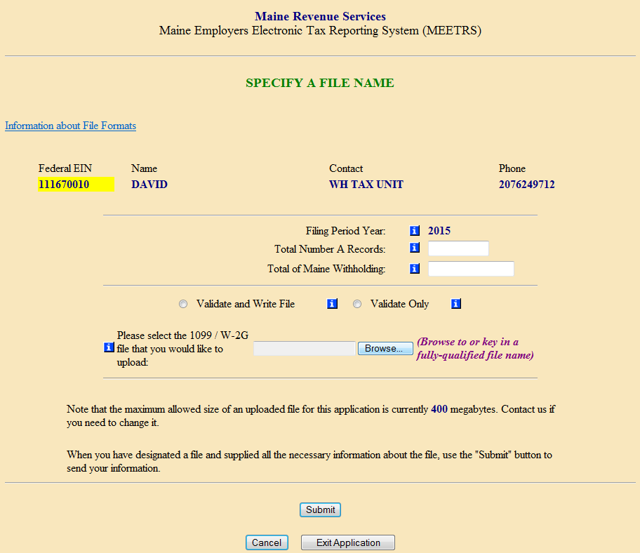

You need to enter the Total Number A Records and the Total of Maine Withholding contained in the file to upload a 1099/W2-G file. The Filing Period Year is hard coded for the currently due tax year.

MEETRS Upload warns that the operation may take a while! For very large files, there is a substantial delay (minutes).

Press the OK button on the dialogue box to continue.

The Validate and Write File option will transmit the file, if there are no errors. If there are errors, the entire file will be rejected and the error messages will be seen on the screen in red above the FEIN, Name, and Contact information.

You can choose Validate Only to verify the file without writing it to the MRS database. If there are no errors, the file must be resubmitted using the Validate and Write File option.

**QUARTERLY RETURNS**

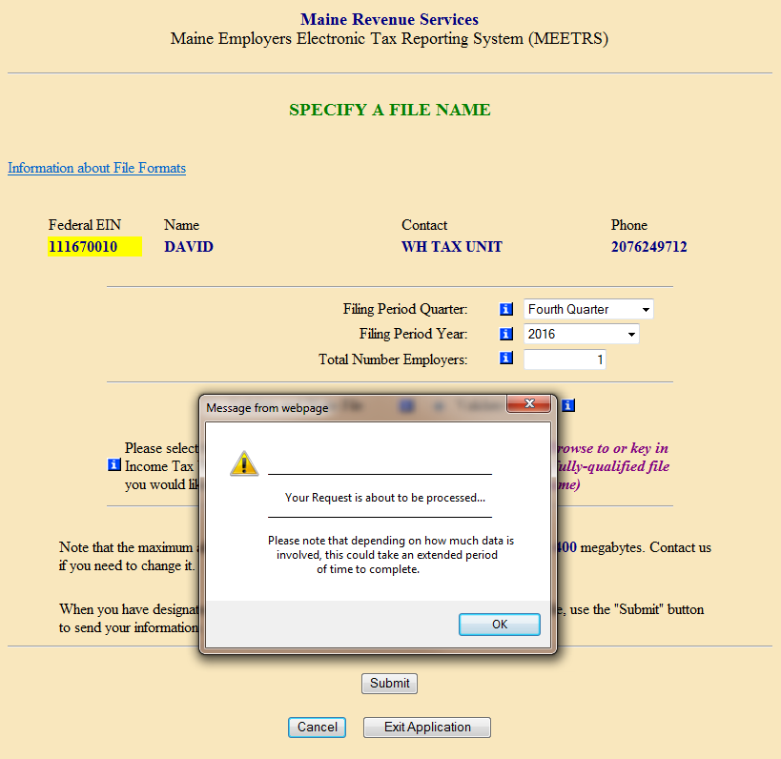

Payroll processors can transmit more than one file per quarter if necessary, but only original returns are accepted. Any duplicate Withholding Account ID Numbers across the files on the Employer (E) Record will cause the 2nd and subsequent files to be rejected.

**Feedback Examples**

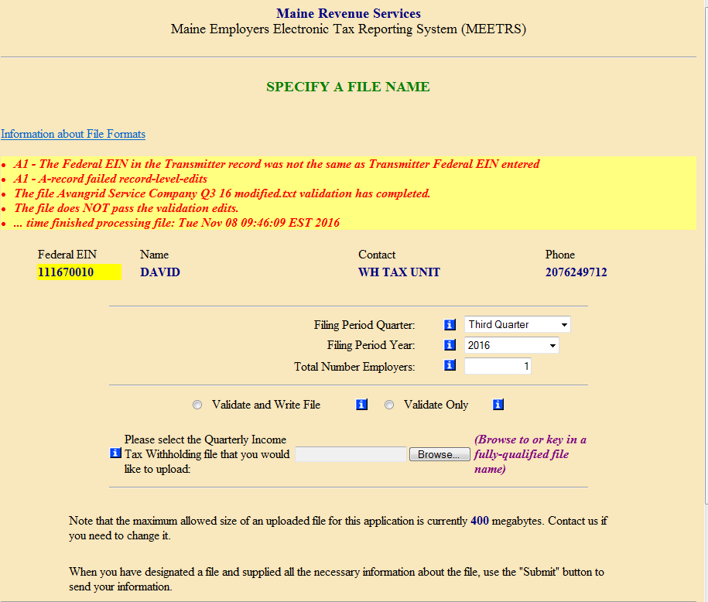

The file is checked for conformity with MEETRS file format specifications and content accuracy. The entire file is rejected if it fails any of the system edits and error messages display the location and a brief explanation.

Files must have valid account numbers. MEETRS file validations will check to ensure Maine withholding or Maine unemployment account numbers are valid and active on the Maine Revenue Services system.

* Any transmittals containing accounts with “applied for” status will be rejected.
* Withholding files; the total withheld on the “T” record must match the accumulated amount acquired by summing the total withheld from each “S” record.
* Unemployment files; the total gross wages reported on the “T” record must match the accumulated amount acquired by summing the total gross wages from each “S” record.

Confirmation

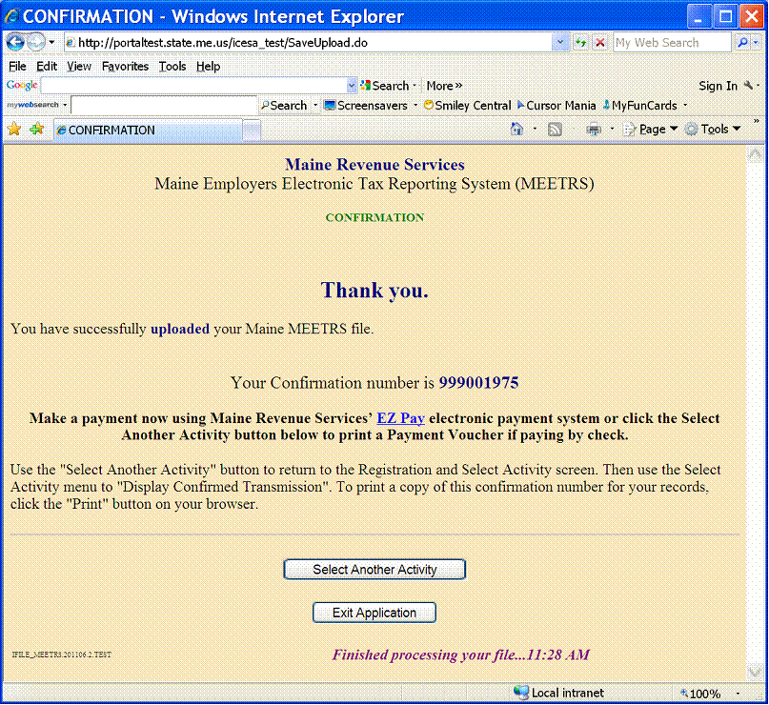

If the file passes all the edits, the file is uploaded and the confirmation number is shown when the process is complete.

If you are paying by check, choose Select Another Activity to return to the Registration Screen, then in the Select Activity field, choose Print Pay Voucher(s). Detailed instructions begin on page 28.

**Display Confirmed Transmission**

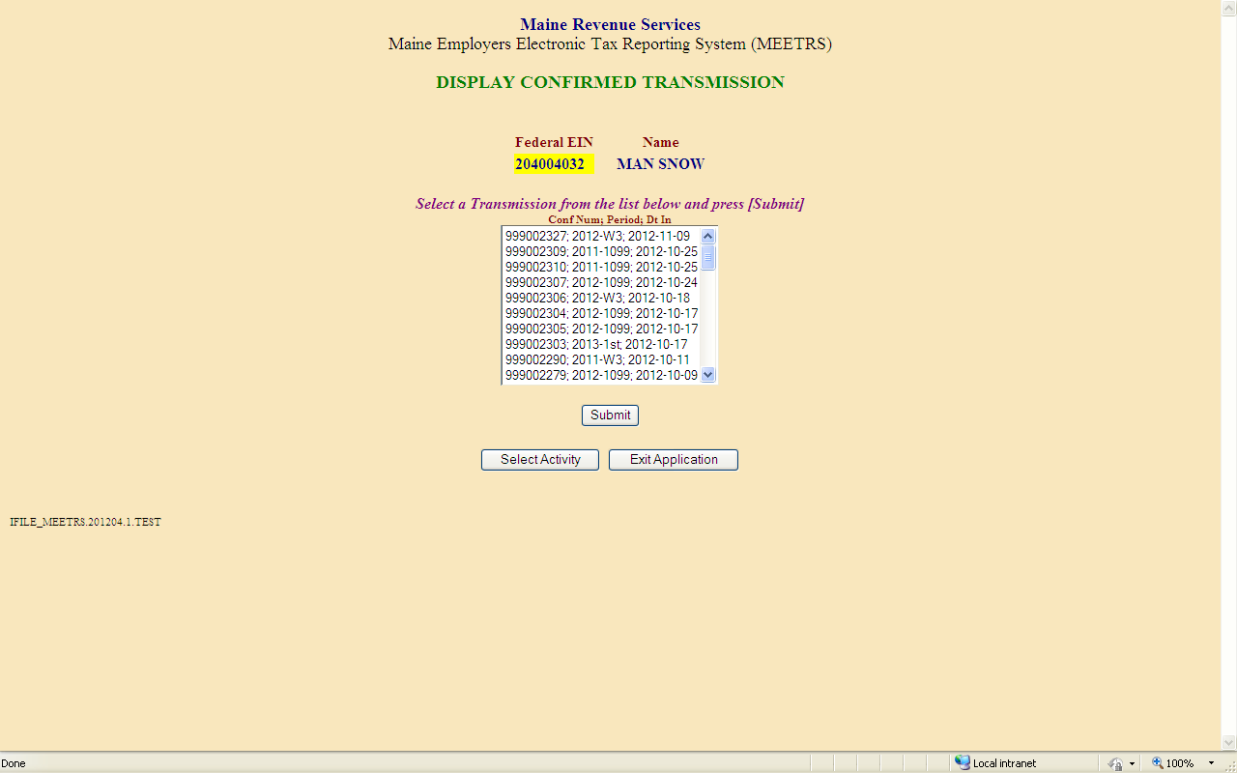

When you select Display Confirmed Transmission from the Select Activity box, a list of prior transmissions is displayed with confirmation number, payment year and qtr paid (or just filing year for W-3ME, W2, and 1099/W2-G transmissions), and date of the upload. Select the one you wish to view and click the Submit button.

Display Transmission Detail List

**Quarterly Files**

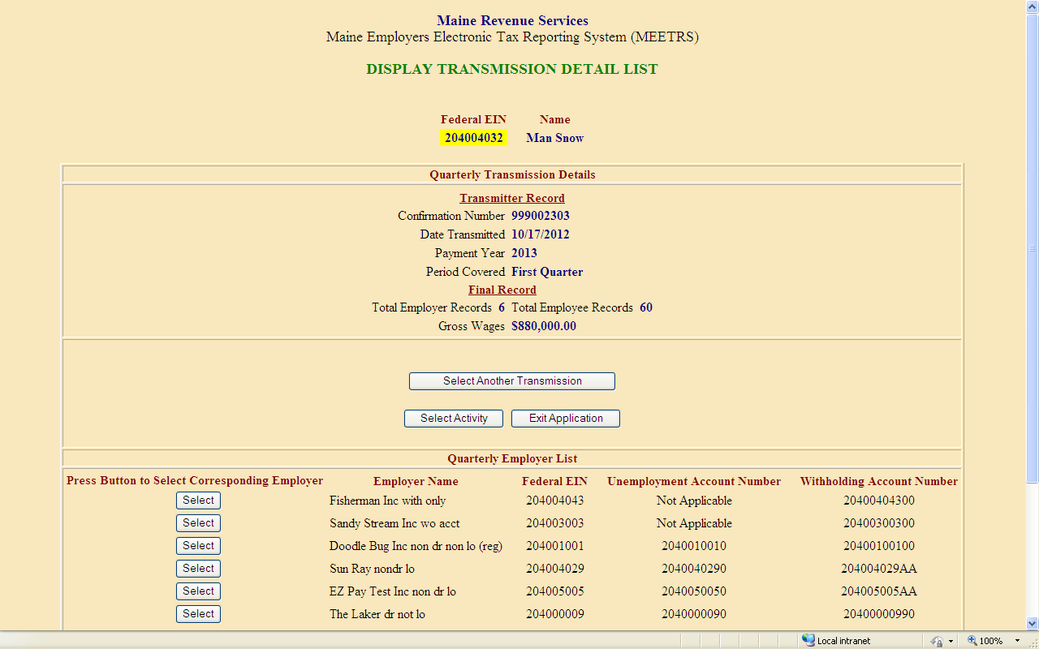

Information about the Quarterly transmission is displayed in two parts. The first part above shows the general Transmission details (including the number of employers, the number of employees and gross wages).

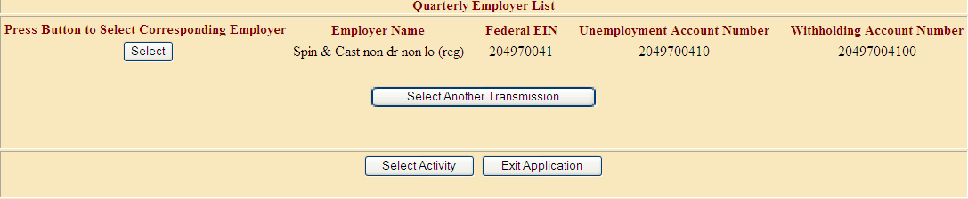

The second part shows a list of employers on the file. By clicking the Select button next to an employer, you will be presented with the Employer Detail List, providing more details (about the employer and its employees).

**W-3ME Files**

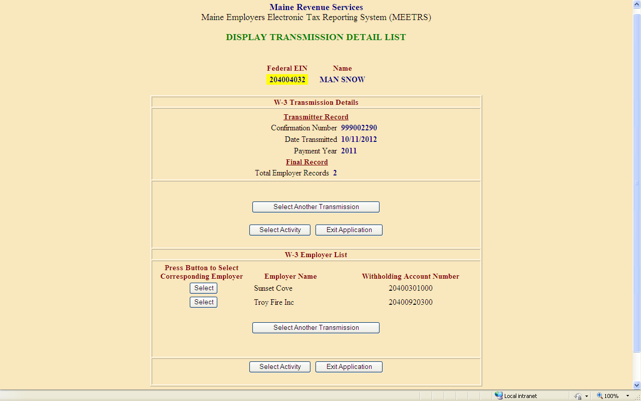

Information about the W-3 ME transmission is displayed in three parts. The first part above shows the general Transmission details (including the number of employers).

The second part (above) shows the list of employers on the file. By selecting an employer in the list, then clicking the Submit button, you can drill down to the Employer Detail List to get more details about that employer.

You can click the Select Another Transmission button to continue reviewing the material for other transmissions. By clicking Select Activity, you can return to the Registration page to select another Activity. Or you can quit the application by clicking the Exit Application button (which means to log out of the application and bring up the MRS home page).

Display Employer Detail List

When you select the employer you want to view, information about that employer is provided for Quarterly and W-3 ME uploads.

**Quarterly Files**

When you select the employer you want to view, information about the employer is also displayed in two parts. The first part shows the general Employer details (including the account numbers and wage information).

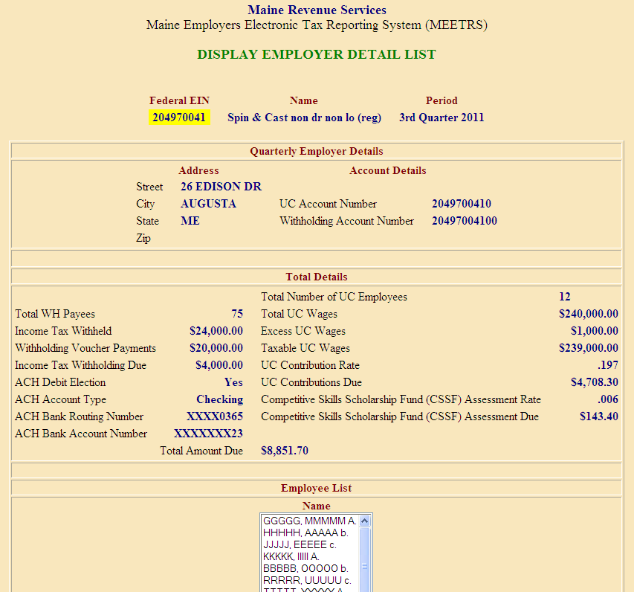

The second part shows a list of employees for this employer. By selecting an employee in the list, then clicking the Submit button, you can drill down to get more details about that employee.

You can click the Select Another Employer button to continue reviewing the material for this transmission. By clicking Select Activity, you can return to the Registration page to select another Activity. Or you can quit the application by clicking the Exit Application button (which means to log out of the application and bring up the MRS home page).

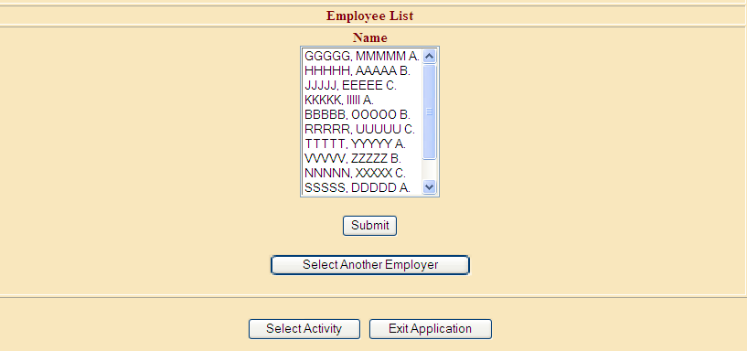

**W-3ME Files**

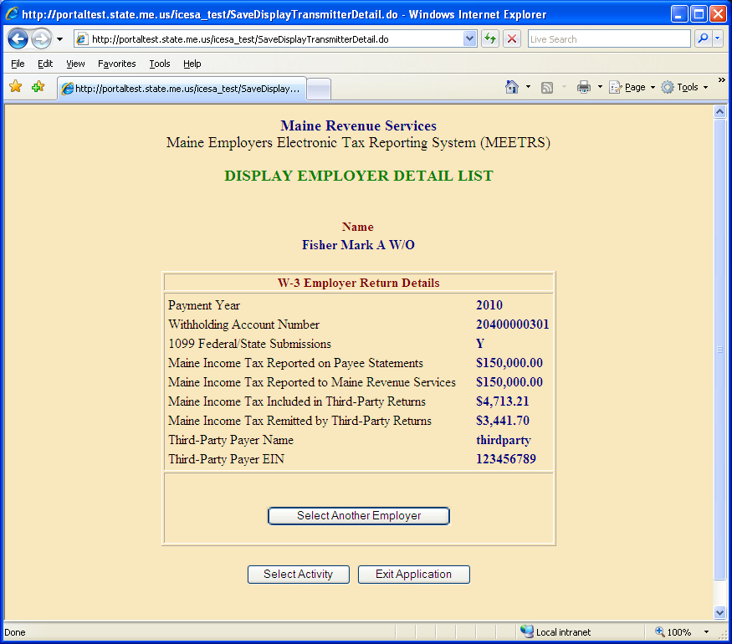

The third part of the W-3 ME transmission shows the details about an employer.

You can click the Select Another Employer button to continue reviewing the material for this transmission. By clicking Select Activity, you can return to the Registration page to select another Activity. Or you can quit the application by clicking the Exit Application button (which means to log out of the application and bring up the MRS home page).

**Display Employee Detail**

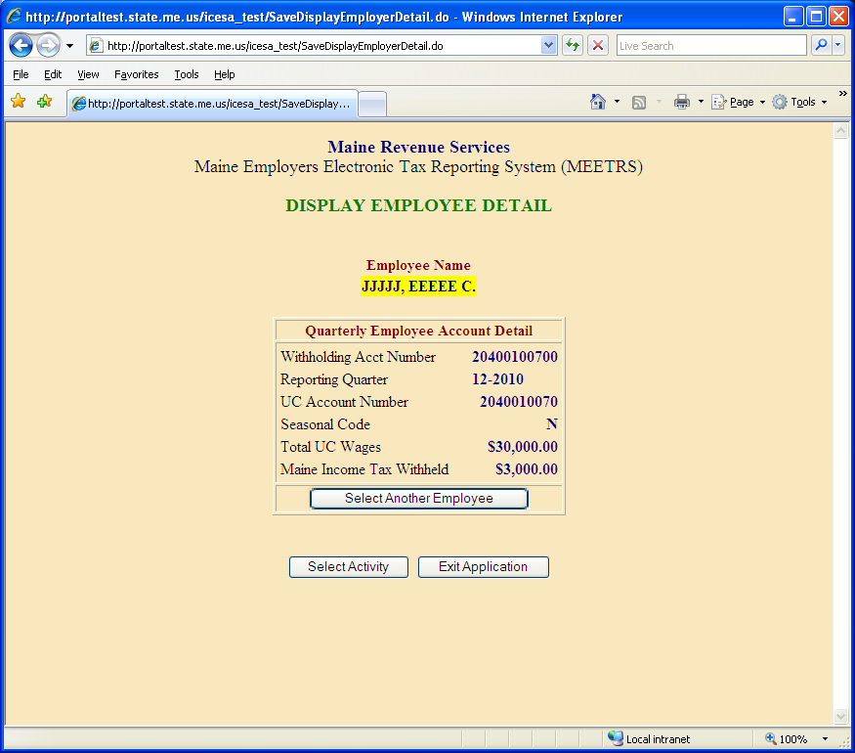

After reviewing the details you can either look at another Employee’s details by choosing Select Another Employee, or click the Select Activity button to return to the Registration page. If you are completely finished, you may click the Exit Application button to go to the MRS home page.

Display Transmission Summary

**W2 Files**

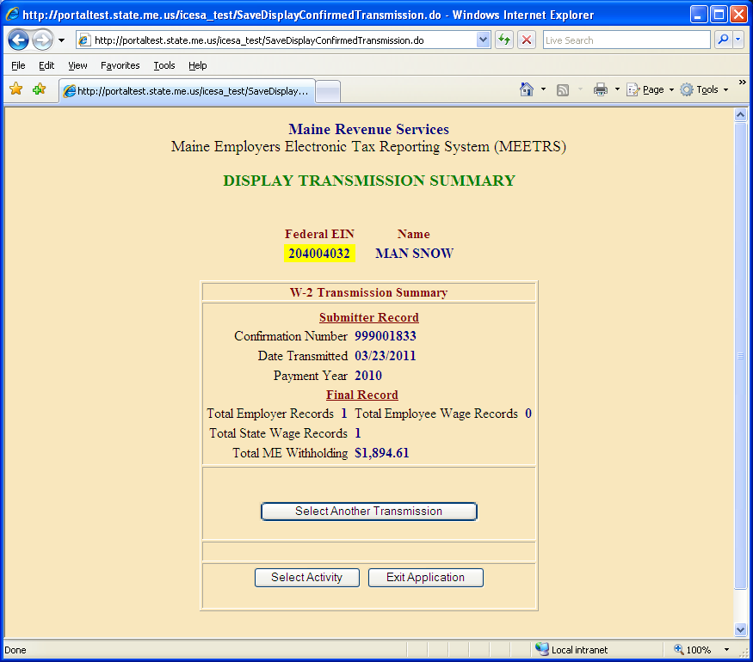

Information about the W2 transmission is displayed on one screen. The example above shows the general Transmission details (including the number of employers, the total number of employee wage records [if provided], the total number of state wage records and the total ME withholding). Only summary information is available for W2 transmissions.

**1099/W2-G Files**

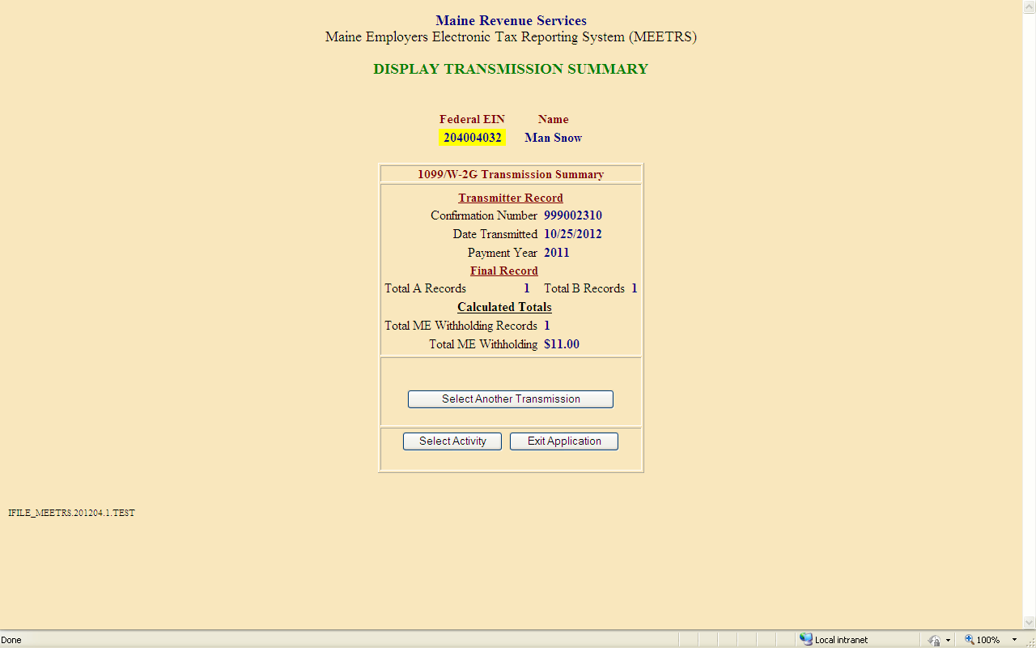

Information about the 1099/W2-G transmission is displayed on one screen. The example above shows the general Transmission details (including the total number of A records, the total number of B records [if provided], the total number of ME withholding records and the total ME withholding). Only summary information is available for 1099/W2G transmissions.

Print Pay Voucher(s)

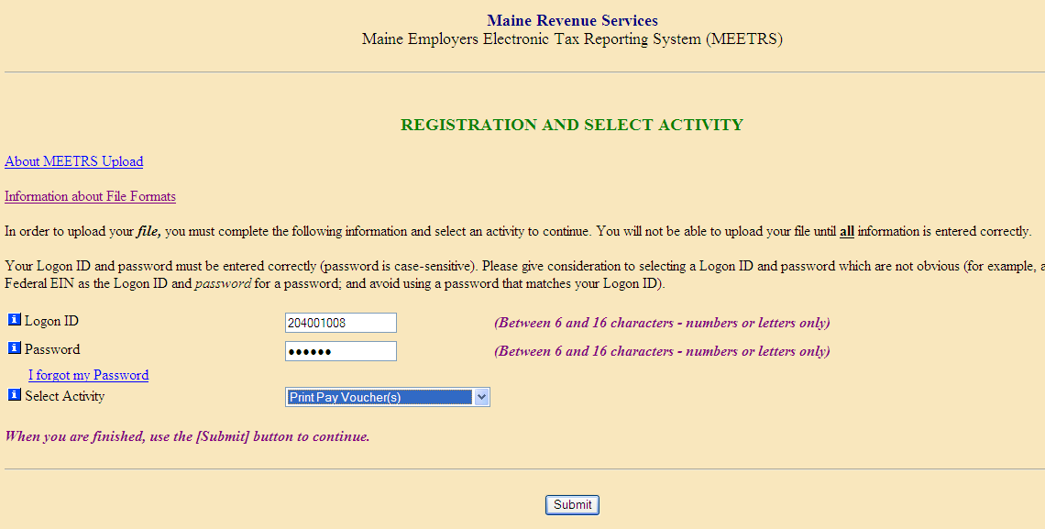

To print a pay voucher, select Print Pay Voucher(s) on the Registration and Select Activity page.

This will bring you to a list of confirmed transmissions, from which you can select a transmission by clicking the confirmation number in the list. Then click the Submit button.

*Note: This choice applies to Quarterly transmissions only.*

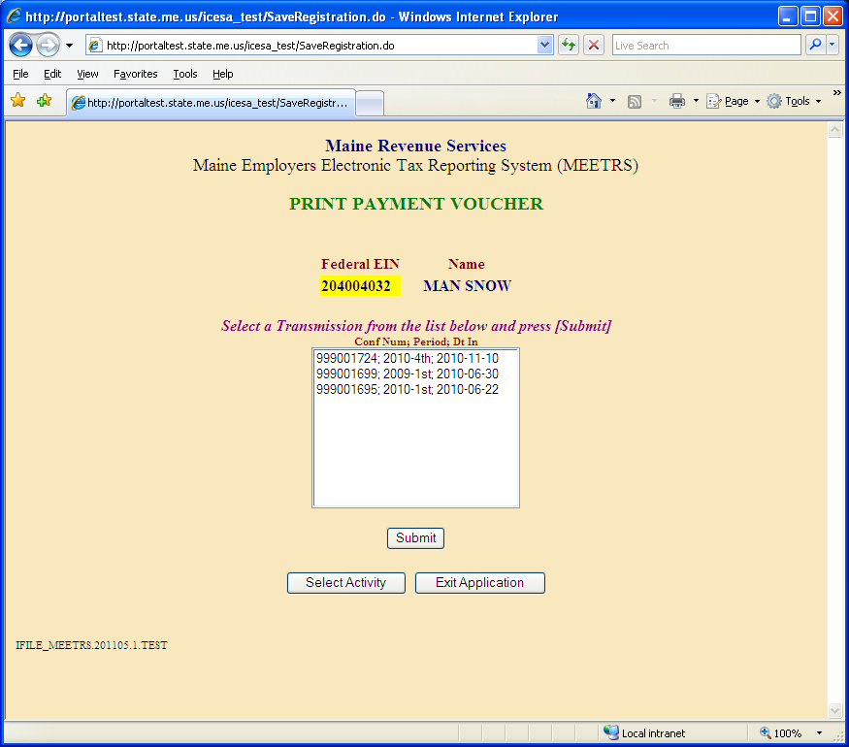

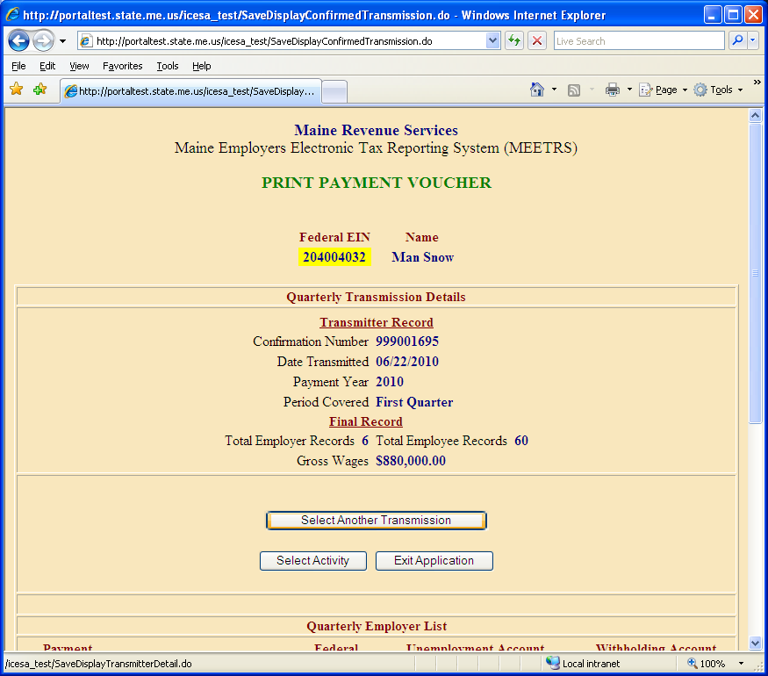

The general details about the transmission will be displayed. Click the Select button of the employer for whom you need the pay voucher.

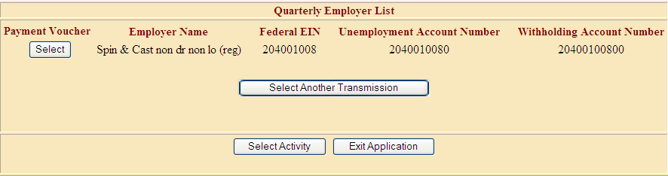

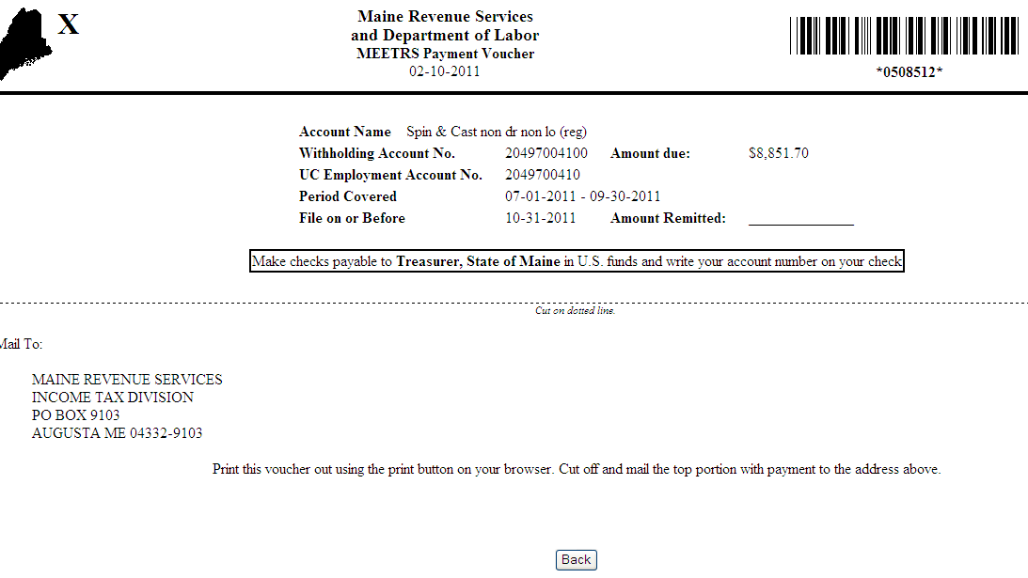

Use the browser controls to print the voucher, then click the Back button on the web page. Do not use your browser’s back button.